**Linux Chat Application**

Oscar Kwan

Krystle Bulalakaw

User Manual

March 23, 2016

# Application Overview

This is a Linux chat application created using Qt. The networking calls are handled by Linux C++ network calls. The chat application features a tab style widget that has a chat and connect tab. The server is a console application that needs to be started first in order for clients to connect. Multiple clients can be connected at any given time and is tracked by the server.

## Setting it up / Compiling

### Server

To begin setting the application up we need to compile and run the server.

1. **Launch terminal**
2. **Navigate to Source/Server/**
3. **Type *gcc -Wall -o server server.cpp***
4. **Type *./server <port>***
5. **If *<port>* is omitted, the default value 7000 will be used.**
6. **A precompiled version is available in the root directory, where you can simply type *./server***

The server is now successfully running. To quit at any time press <**CTRL+C>.**

### Client

The client is built using Qt. This is one way of compiling and running the application.

1. **Ensure qt-develop and qt-creator are installed on your Linux system**
2. **Launch terminal**
3. **Navigate to Source/build-linuxchat-Desktop_Qt_5_5_1_GCC_64bit-Debug**
4. **Type *make***
5. **Type *./linuxchat***
6. **A precompiled version is available in the root directory, where you can simply type *./linuxchat***

# Chat Client Application

**Connect to server**

In order to begin chatting with your friends, navigate to the connect tab and enter in your **username, IP address,** and **port.** Make sure the port is consistent throughout all the users and the IP address is the address of the server.

 

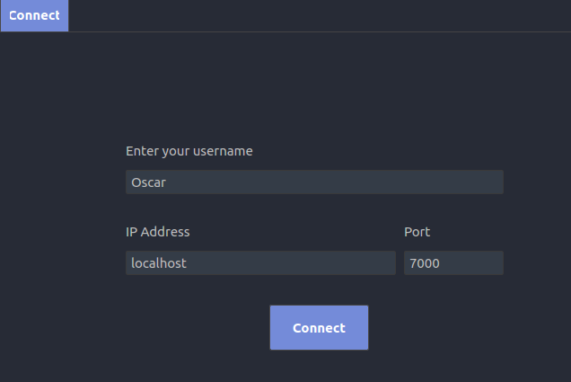

**Talking with friends**

To start chatting with your friends, make sure the label on the top left is **Online**. A list of users are displayed on the left and you have one main channel to talk with everyone.

Start by typing in the chat field and press <Enter> on your keyboard or click the **Send** button.

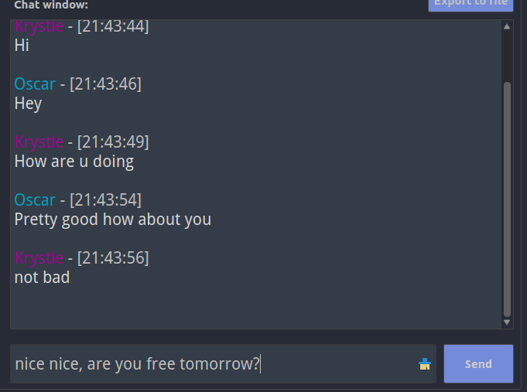

**Exporting a log file**

By pressing the **Export to file** button, your chat history will be saved to a file called **“log.txt”.**



**Disconnecting**

If you wish to go offline, navigate to the Connect tab once again and click the **Disconnect** button. Your status will be set to offline and the list of connected clients will no longer appear. You can type in the chat box if you want, but no one will see!

 